Name:

ID:

M6 Exam

Part A

1. Consider the URL:

A B C

https:// [www.apple.com](http://www.apple.com) /red.txt

Which part of the URL is the path?

|  |  |
| --- | --- |
| A | C |
| B | None |

1. Consider the following JavaScript:

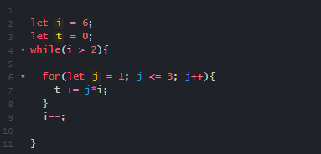

What will be the final value of t?

|  |  |
| --- | --- |
| 6 | 18 |
| 36 | 108 |
| 240 | 204 |
| 104 | 38 |

1. What is the base 10 number **15** in octal?

|  |  |
| --- | --- |
| 1 | 15 |
| 10 | 16 |
| 22 | 17 |
| 13 | 20 |

1. How many children does the body tag have?

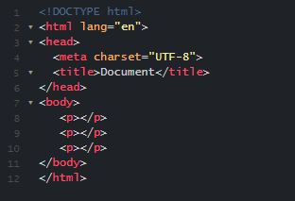

|  |  |
| --- | --- |
| 1 | 2 |
| 4 | 3 |
| 5 | 0 |
| 6 | 7 |

1. Which of the following best describes a bot net disabling a remote server by sending excessive requests:

|  |  |
| --- | --- |
| Phishing | Spear phishing |
| XSS | Social engineering |
| DDOS | Rootkit |
| Ransomware | Rainbow table |
| Adware | None |

1. Which best describes encrypting somebody’s files and demanding payment?

|  |  |
| --- | --- |
| Phishing | Spear phishing |
| XSS | Social engineering |
| DDOS | Rootkit |
| Ransomware | Rainbow table |
| Adware | None |

1. Which of the following terms best describes max amount of data that can be transmitted through a network?

|  |  |
| --- | --- |
| pipeline | latency |
| bit | flow rate |
| bandwidth | lag |

Part B

1. Make a table similar to this, except the names should be green:

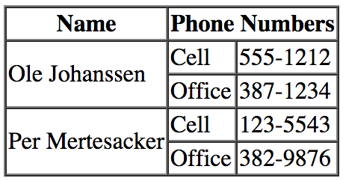

*paste code below:

1. Make a simple web page that contains a button and a paragraph with the id of count whenever this button is pressed increment the count by 1 and update the paragraph text. Paste code below: